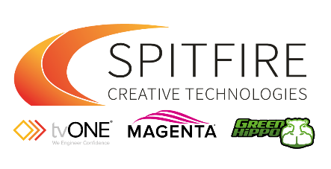
Spitfire Creative Technologies
Junior Graphic Designer
Reporting to: Design Manager
Cincinnati, Ohio
Job Summary
We are looking for a talented Junior Graphic Designer to join our Marketing team, supporting the Design Manager and graphic creation for our Audio-Visual Install and Live Entertainment brands. In this role, you help design and create both print and digital marketing materials for advertising, product marketing and external events. Candidates should be familiar with Adobe Photoshop, Illustrator, InDesign, and other graphic design applications. This is a mid-level role that reports to senior employees. Candidates should be able to produce high-quality materials while adhering to deadlines. Please submit a portfolio of your past work when applying to this job.
Junior Graphic Designer Duties and Responsibilities
- Design digital and print collateral
- Create supporting graphics and imagery for marketing campaigns.
- Contribute to layout, typography, and photography decisions
- Take direction from the Design Manager and assist with graphic tasks as required
- Document and organize current graphic materials
- Create and update product collateral and brochures
- Create and brand general documentation including blogs and whitepapers
- Execute Product photography when required
- Support miscellaneous sales graphic requests
- Develop supporting graphics to support Training and Communications initiatives (ppts and webinar graphics).
Junior Graphic Designer Requirements and Qualifications
- Bachelor’s degree in graphic design strongly preferred
- Experience in an internship or entry-level graphic design role
- Familiarity with Adobe Creative Suite, including Photoshop, Illustrator, and InDesign
- Attention to detail
Please submit a portfolio of past work when applying to this role
Please submit your CV and portfolio to jobs@spitfirect.com

